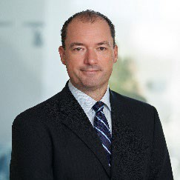  Deloitte | Serge Berube  Serge is a Partner with Deloitte, Cayman Islands, specializing in the provision of assurance and advisory services to the alternative investment industry. Serge has over 25 years of public accounting experience, including 20 years with Deloitte in the Cayman Islands. Serge serves a diverse set of hedge funds, fund- of-funds, private equity funds and structured finance clients.  In addition to his client service commitments, Serge oversees Deloitte’s business development group. In this capacity, he assists investment advisors in structuring and establishing new alternative investment vehicles. Serge is actively involved in helping his clients understand the various regulatory, structural and operational frameworks of the industry. He has spoken at industry conferences and participates in delivering technical training to financial services industry service providers.  Serge is a Certified Public Accountant, a Canadian Chartered Accountant and a Chartered Alternative Investment Analyst. Serge holds a Bachelor of Commerce from the University of Alberta, Canada.
Council/Committee Membership
Council

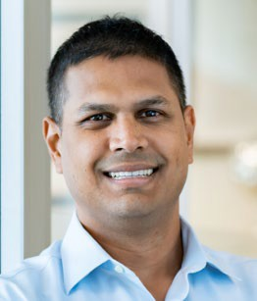  PwC | Marlon Bispath  Marlon is a partner in PwC Cayman Islands' and has more than 20 years of professional experience in assurance services with PwC. He is also the firm’s risk management partner with responsibility over the Cayman assurance practice.  Marlon's experience covers audits of statutory authorities, operating companies in both the telecoms and energy sectors and financial services clients comprising large multinational banks, operating both in Cayman and other Caribbean jurisdictions; fiduciary and trust companies; and alternative investment companies encompassing a variety of fund structures and strategies.  Marlon is a fellow of the Association of Chartered Certified Accountants.
Council/Committee Membership

Council
Public Practice Committee-Chair

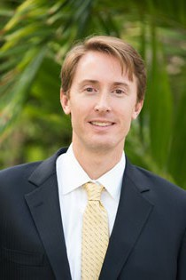  BDO | James George  James is an audit partner at BDO with over 20 years of experience in the offshore financial services industry. James has worked with a wide variety of clients from small start-up entities to global financial institutions, all with an equally diverse array of investment strategies and reporting requirements. His audit experience primarily encompasses hedge funds, private equity, and alternative investment vehicles, and he has extensive experience in the application of both US GAAP and International Financial Reporting Standards (IFRS).  James currently serves on the Council of the Cayman Islands Institute of Professional Accountants (CIIPA) where he is active on a number of committees. He has a B.S. in Accounting from the University of Southern California and is also a member of the American Institute of Certified Public Accountants and the Illinois CPA Society.
Council/Committee Membership
Council - Secretary
Quality Committee
Audit Committee – Chair
International Relations Committee – Chair
Membership & Licensing Committee

Edward Gwekwete

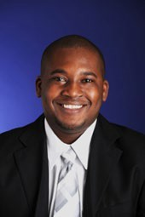

KPMG
Ed is an audit partner with KPMG in the Cayman Islands and is the Audit Quality and Professional Practice Leader for the Cayman firm as well as the KPMG Islands Group. Ed has more than 20 years of experience providing audit services to a wide range of financial services clients, the last 12 of which have been focused on investment management and investment fund clients, including mutual funds, hedge funds, private equity/venture capital investment companies, and investment advisers.

Ed has served as quality control reviewer for many of KPMG largest asset management clients in the Cayman Islands and is part of KPMG’s Global Asset Management technical group.

Over the past 5 years, Ed has been focused on building out the Audit Quality and Professional Practice group for the entire KPMG Islands Group where his responsibilities include monitoring activities at accounting and auditing standard-setting bodies and regulators and formulating views relative to investment management and investment company matters; consulting with KPMG engagement teams and clients regarding technical accounting, reporting, and audit issues in the investment management and funds industry; and assisting in developing and instructing KPMG’s investment funds training courses.

Ed is a CFA charterholder and a Certified Financial Risk Manager and has broad experience with accounting, reporting, operational, and compliance requirements of investment funds and investment advisers, including complex investment types and products.
Coun

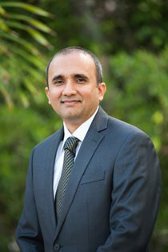  KPMG | Rennie Khan  Rennie is an audit partner at KPMG. Prior to joining KPMG he worked at two other accounting firms in the Cayman Islands. Soon after coming to the Cayman Islands in 2001 he joined CIIPA’s training committee and was an active participant until 2015. Rennie currently serves on the membership and licensing and audit committees and previously on the quality, public practice and membership engagement committees. He presented at CIIPA’s annual accounting update for 2 years and was responsible for delivering internal technical training at his previous firms, both locally and internationally. Rennie was an active participant in the organizing committee for the Government Professional Development Week for 2 years.  Rennie is a fellow of the Association of Chartered Certified Accountants and gained his experience conducting audits on funds, private banks, trust companies, insurance captives and other local entities.  He authored various articles for local publications on the impact of evolving accounting standards on the local financial sector. Outside of work, Rennie is an active member in the community, having participated in the Big Brother Big Sister Programme, CIIPA’s mentoring program, Chamber of Commerce’s mentoring program, Fresh Air Fund and volunteered time at the Sunrise Adult Training Centre.
Council/Committee Membership
Council - President
Membership & Licensing Committee Audit Committee

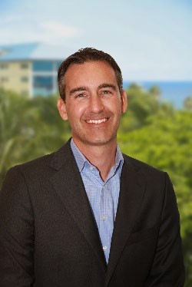  Deloitte | Francois Lamontagne  Francois is a partner with the Audit and Assurance Services group of Deloitte. He has more than 25 years’ experience with Deloitte, and has worked in Canada, the British Virgin Islands and the Cayman Islands where he concentrates on the financial services industry servicing the banking, trust and investment fund sectors.  While working in two different offshore jurisdictions, Francois has developed extensive experience with private banks as well as large offshore and onshore fund structures, investment companies, intermediate holding companies and special purpose vehicles. In addition to providing audit services, Francois has been involved with internal audit and with Service Organization Control engagements (SSAE 18 and ISAE 3402).  Francois holds a number of leadership positions within Deloitte such as the Client and Industry leader for Banking and Securities. He was also part of the Deloitte Global Advisory Council in 2014 and 2015 under Deloitte Global CEO Barry Salzberg.  Francois is a member of the Canadian Institute of Professional Chartered Accountants and the Cayman Islands Institute of Professional Accountants. Francois is a past president of the Cayman Islands Institute of Professional Accountants.
Council/Committee Membership

Council
Public Sector Committee

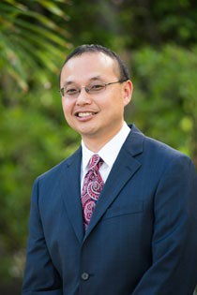 | Ben Leung  Ben is a member of the Institute of Chartered Accountants in England and  Wales (ICAEW). He has been on island since 2001 and applied to be a member  of (then) CISPA upon arrival.  He has been the Managing Partner of EisnerAmper Cayman Ltd, an audit firm,  since 2007. He runs the practice which specializes in audits of CIMA regulated  entities, mainly captive insurance companies, hedge funds, and private funds.  He is registered as a Director with CIMA pursuant to the Directors Registration  and Licensing Law and is a member of the Cayman Islands Directors  Association. He is a Director at EisnerAmper Governance Services.  He has served on CIIPA’s Council since 2011 and has been Chair of the Training  Committee since 2013. He audits, on a pro-bono basis, the Cayman Islands Red  Cross and Cayman Finance.
EisnerAmper
Council/Committee Membership
Council
Training Committee - Chair (eleven years)

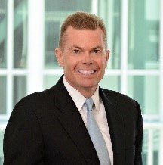 | Mike Mannisto  Mike is a partner in the Bahamas, Bermuda, British Virgin Islands and Cayman  Islands region (BBC) of EY’s Financial Services Organization. He is the assurance managing partner and banking sector leader for the BBC region. He has approximately 29 years of experience with EY, having spent 25 years with the Cayman Islands firm.  Mike works with a number of EY’s asset management clients and has served  several global priority asset management accounts and multi-jurisdictional  fund structures. Mike also serves a wide variety of other financial services  clients including private equity funds, banks and insurance companies.  Mike holds an Honours Bachelor of Commerce degree with a major in  accounting from Lakehead University. He is also a Canadian CPA and a member  of the Canadian Institute of Chartered Professional Accountants.  Mike is a past president of the Cayman Islands Institute of Professional  Accountants (CIIPA), and currently holds the position of Council Member.  Mike is also a past Chairperson of the Board of Trustees for the International  College of the Cayman Islands (ICCI) and is currently a Trustee.
EY
Council/Committee Membership
Council

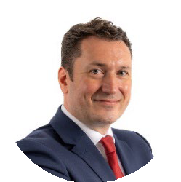  Grant Thornton | Ewan McGill  Ewan is a Partner at Grant Thornton in the Cayman Islands. Specialised in financial services, Ewan provides audit, assurance, and advisory services to a broad range of clients, predominantly in the asset management, capital markets and banking sectors.  Ewan has over 20 years’ experience in the offshore environment. Prior to joining Grant Thornton in the Cayman Islands in 2021, he worked for a Big 4 firm in Jersey, Guernsey, Bermuda, Singapore, and the Isle of Man. He is currently the E&I Partner and Risk Management Partner at Grant Thornton and has previously held other roles supporting Audit Quality reviews.  Ewan is a Chartered Accountant (Institute of Chartered Accountants of Scotland) and holds a Bachelor of Commerce degree from the University of Edinburgh.  Council/Committee Membership  Council  Quality Committee

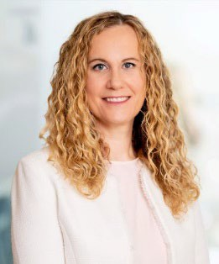  Deloitte | Laurie Mernett  Laurie is an audit partner with Deloitte Cayman Islands. Laurie has more than 20 years of professional experience with Deloitte, having worked for Deloitte Canada prior to joining Deloitte Cayman. She specializes in the provision of assurance and advisory services to private investment funds and other Cayman based financial services entities.  Laurie has numerous leadership roles within the Cayman office and the Deloitte Caribbean and Bermuda region, focusing on training, audit innovation, and audit technical matters. She has participated in panel discussions at various industry events in the Cayman Islands on these focus areas.  Laurie holds a Bachelor of Commerce and a Bachelor of Arts degree from the University of Manitoba, Canada. She holds the Canadian Chartered Professional Accountant (CPA, CA) and the US Certified Public Accountant designation and is a member of the American Institute of Certified Public Accountants. Laurie is also actively involved in leadership of the Cayman Islands chapter of 100 Women in Finance serving as a Gala Committee member and co-chair of the Main Committee.
Council/Committee Membership
Council
Membership & Licensing Committee Membership Engagement Committee - Chair

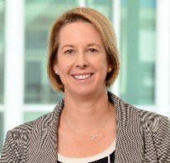  EY | Rosa Nolan  Rosa is now a Partner in the Cayman Islands office of the Bahamas, Bermuda, British Virgin Islands and Cayman Islands sub-area of EY’s Financial Services Organization.  Rosa has over 18 years of audit experience with EY and has spent the past thirteen years serving a variety of financial services clients including alternative fund managers, private equity funds, hedge funds and fund administrators. She has considerable experience with US GAAP, IFRS and SEC requirements as well as Cayman regulatory matters.  In addition to her clients encompassing start-ups to global multibillion-dollar complexes, her experience includes SOC 1 reporting, agreed-upon procedures engagements and global investments performance standards assignments.  Rosa holds a Bachelor’s degree in Commerce, with honors, and is a member of the Chartered Accountants of Australia, New Zealand and the Cayman Islands Institute of Professional Accountants (CIIPA).
Council/Committee Membership
Council – Vice President
Membership & Licensing Committee Chair
Ethics Committee - Chair

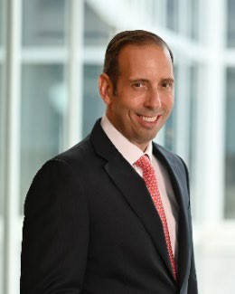  EY | Jeff Short  Jeff is a Partner at EY Cayman Ltd. and Sector Leader for Wealth & Asset Management for the EY Region of the Bahamas, Bermuda, British Virgin Islands and Cayman Islands. He has over 25 years of experience with the EY organisation, the majority of which have been in the Cayman Islands office.  Jeff’s career has been focused in the financial markets area, serving asset managers, hedge funds and private equity funds. His clients encompass start-ups to global multibillion-dollar hedge fund complexes.  Jeff graduated with a Bachelor of Science, Accountancy, from Babson College. He is a Member of the American Institute of Certified Public Accountants, the Massachusetts Institute and New York State Society of Certified Public Accountants. He is also a board member and treasurer for Special Olympics Cayman Islands.
Council/Committee Membership

Council
Investigation Committee
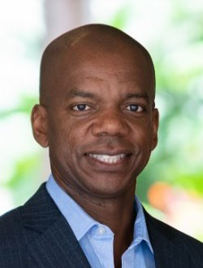  PwC | Peter Small  Peter Small is a Partner in the Asset Management group with PwC Cayman Islands. He has more than 20 years of professional experience in assurance and business services with PwC in the Cayman Islands and Boston. Peter is engagement leader on several Alternative Investment Funds with a variety of different investment strategies and structures. He also leads a team of Private Equity and Venture Capital Fund specialists within the Asset Management group.  Peter holds a Bachelor of Science (Accounting) degree from Florida State University. Peter is a licensed Certified Public Accountant in the state of New York, a member of the American Institute of Certified Public Accountants, a member of the Cayman Islands Institute of Professional Accountants (CIIPA) as well as a CIIPA Past President.
Council/Committee Membership

Council
Investigation Committee - Chair

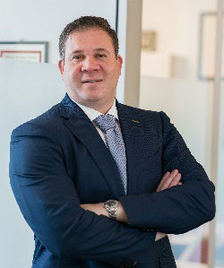  PwC | Craig Smith  Craig is an assurance partner with the Asset Management Group with the PwC firm in the Cayman Islands. He has 25 years of experience with PwC in the Cayman Islands and New York.  Craig serves a diverse range of clients in the alternative asset industry from around the globe and also works with other PwC network firms on a referred auditing basis.  Craig's clients range from small emerging managers to large institutional managers and encompass a variety of structures and strategies. Craig welcomes the chance to speak in industry panels and training sessions.  Craig holds a Bachelor of Science degree in Accounting and International Business from The Pennsylvania State University. Craig is a licensed Certified Public Accountant in the State of New York and a CFA charter holder. He is a past President of the Cayman Islands Institute of Professional Accountants (CIIPA) and has served on a number of underlying committees including being the initial chairman of the ethics committee. He is also a member of the American Institute of Certified Public Accountants, the CFA Institute and the CFA Society of the Cayman Islands.
Council/Committee Membership
Council
Membership & Licensing Committee Audit Committee
Ethics Committee

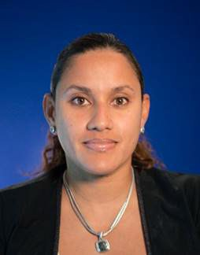  KPMG | Yuri Williams  Yuri leads the Private Enterprise practice for KPMG in the Cayman Islands dedicated to working with the public sector, financial services companies, law firms, entrepreneurs, family businesses and emerging fast growing companies. She has more than 18 years’ experience providing audit and assurance services and has broad experience with accounting and reporting frameworks, such as IFRS, US GAAP and IPSAS and previously led on transition projects from Canadian GAAP to IFRS.  Prior to joining KPMG in the Cayman Islands, Yuri previously worked in the KPMG Toronto office where she led audits of large Canadian public companies and large Canadian subsidiaries of KPMG global clients within the consumer products and automotive industries. She also spent two years on secondment with the KPMG Barbados office.  As a mom of two, Yuri is used to juggling multiple demands at home and work and is also the deputy treasurer for the Jamaica Diaspora Cayman Association.
Council/Committee Membership
Council
Public Sector Committee - Chair

